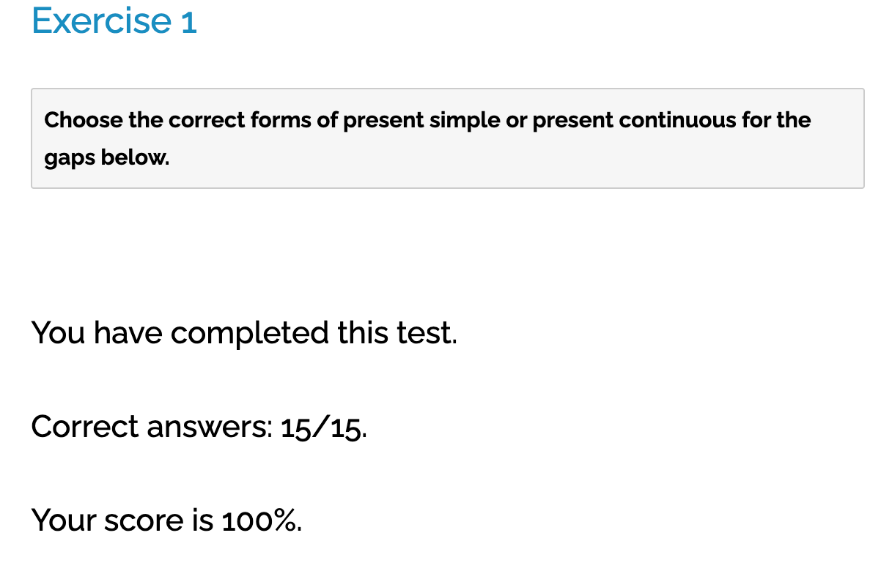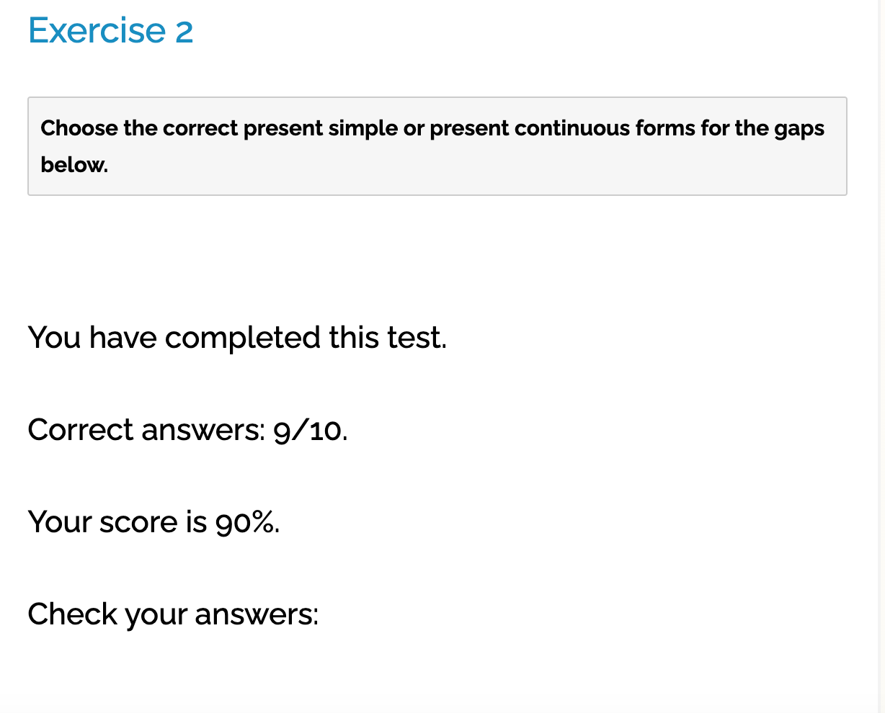

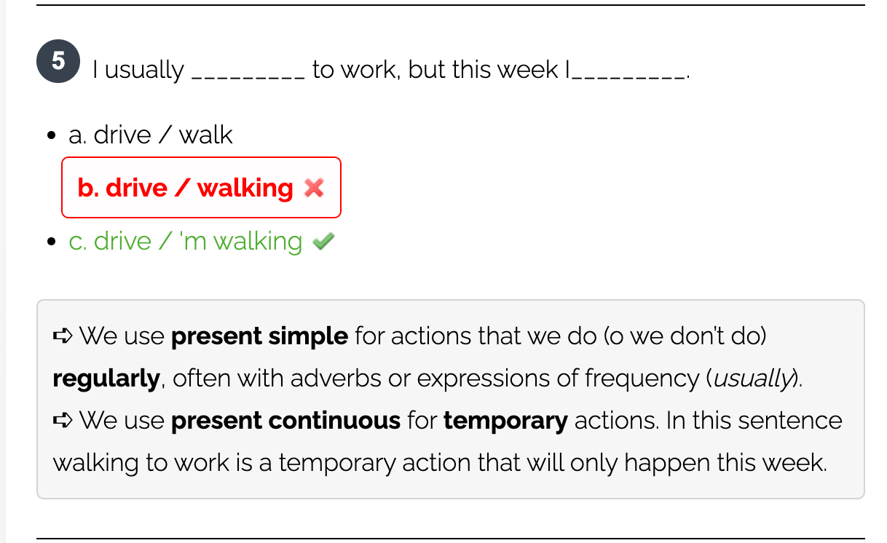

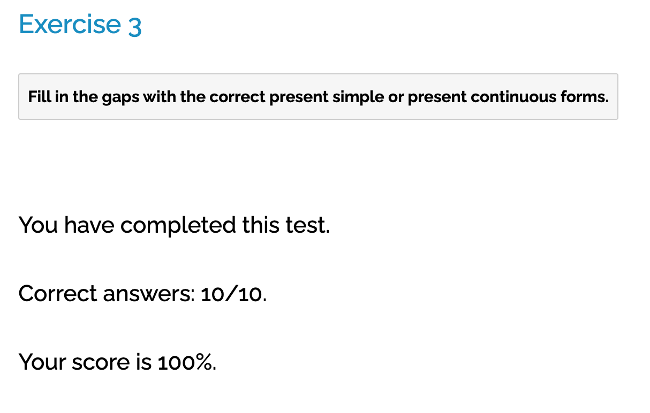

1. Please be quiet. I listen to the news.

* Please quiet! **I'm listening** to the news.

1. Do you like Arsenal or Manchester United? +++
2. My sister never is reading science fiction.

* My sister never **reads** science fiction.

1. Do you sometimes walking to school?

* Do you sometimes **walk** to school?

1. More girls are playing football these days. +++
2. My aunt stays with us this week.

* My aunt **is staying** with us for a few weeks.

1. My uncle regularly speak French for his job.

* My uncle regularly **speaks** French for his jop.

**Use the verbs to complete the sentences. Use the present simple or the present continuous.**

1. Aya prefers classical music to jazz and pop.

1. He has new cabinets in the kitchen.

1. She looks so relieved now that the test is over.

1. Tom doesn`t like Indian food. It’s too hot and spicy for him.

1. The new rock band are appearing on stage tonight.

1. This isn’t Ahmed’s coat. It doesn`t belong to him.

1. The food smells nice.

1. The funfair rides are exciting. We are having a great time!

1. I don`t know where Jane is at the moment.

1. The Browns are fitting of going to the theatre tonight.